The ReLU Family of Activation Functions
Neurova AI Solutions — NLP Training, Task 1

1. The Basic ReLU Function
The Rectified Linear Unit (ReLU) is defined as:
ReLU(x) = max(0, x)
It passes positive inputs through unchanged and clips negative inputs to zero. ReLU became the default hidden-layer activation in deep learning because it is cheap to compute (a single comparison), it does not saturate for positive inputs (unlike Sigmoid/Tanh), and this non-saturation keeps gradients from vanishing on the positive side, which speeds up training in deep networks. Its main weakness is the 'dying ReLU' problem: if a neuron's input stays negative during training, its gradient is permanently zero, so it stops updating and never recovers.

2. Variants of ReLU

2.1 Leaky ReLU
LeakyReLU(x) = x if x > 0, else a·x (a is small, e.g. 0.01)
Behavior: allows a small, nonzero gradient (a) for negative inputs instead of clipping to zero.
Advantage: reduces dying neurons while keeping the same low computational cost as ReLU.
Limitation: the slope a is a fixed hyperparameter — not adapted to the data.
Typical use: general-purpose replacement for ReLU when dead neurons are a concern.

2.2 Parametric ReLU (PReLU)
PReLU(x) = x if x > 0, else a·x (a is learned per channel/layer)
Behavior: same shape as Leaky ReLU, but a is a trainable parameter.
Advantage: lets the network learn the best negative slope for each channel, often improving accuracy on large datasets.
Limitation: adds parameters and can overfit on small datasets.
Typical use: large-scale image classification models (e.g. described in the original ResNet-era PReLU paper).

2.3 Randomized ReLU (RReLU)
RReLU(x) = x if x > 0, else a·x, a ~ Uniform(l, u) at train time; fixed average a at test time
Behavior: the negative slope is sampled randomly during training and fixed (averaged) at inference.
Advantage: acts as a mild regularizer, similar in spirit to dropout.
Limitation: adds stochasticity that can complicate reproducibility; benefit is modest and dataset-dependent.
Typical use: smaller datasets where extra regularization helps reduce overfitting.

2.4 Exponential Linear Unit (ELU)
ELU(x) = x if x > 0, else a·(e^x - 1) (a typically 1.0)
Behavior: smooth and negative-saturating; pushes mean activations closer to zero.
Advantage: zero-centered outputs can speed up convergence; smooth curve avoids a sharp kink at zero.
Limitation: the exponential term is more expensive to compute than a simple max/comparison.
Typical use: deeper networks where faster convergence outweighs the extra compute cost.

2.5 Scaled Exponential Linear Unit (SELU)
SELU(x) = scale · (x if x > 0, else a·(e^x - 1)), a≈1.6733, scale≈1.0507
Behavior: like ELU but with fixed scale/alpha constants chosen so that, under specific conditions (LeCun-normal init, plain feed-forward architecture), activations self-normalize to zero mean and unit variance across layers.
Advantage: can remove the need for batch normalization in qualifying architectures.
Limitation: the self-normalizing guarantee only holds under specific conditions (fully-connected layers, matching initialization); breaks with architectures like CNNs with skip connections or with dropout unless adapted (Alpha Dropout).
Typical use: fully-connected self-normalizing networks.

2.6 ReLU6
ReLU6(x) = min(max(0, x), 6)
Behavior: identical to ReLU but caps the output at 6.
Advantage: bounds activation range, which improves numerical stability under low-precision (int8) quantization.
Limitation: the upper cap can clip useful signal in networks not designed for quantization.
Typical use: mobile and embedded networks (e.g. MobileNet) designed for quantized inference.

2.7 Gaussian Error Linear Unit (GELU)
GELU(x) = x · Φ(x) where Φ is the standard normal CDF (often approximated with tanh)
Behavior: smooth curve that weights inputs by their probability under a Gaussian, allowing a small negative output near zero instead of a hard cutoff.
Advantage: smoothness (no kink at zero) tends to help optimization in very deep architectures; empirically strong in Transformer models.
Limitation: more expensive to compute than ReLU (requires an erf or tanh approximation).
Typical use: Transformer-based architectures such as BERT and GPT.

3. Activation Curves
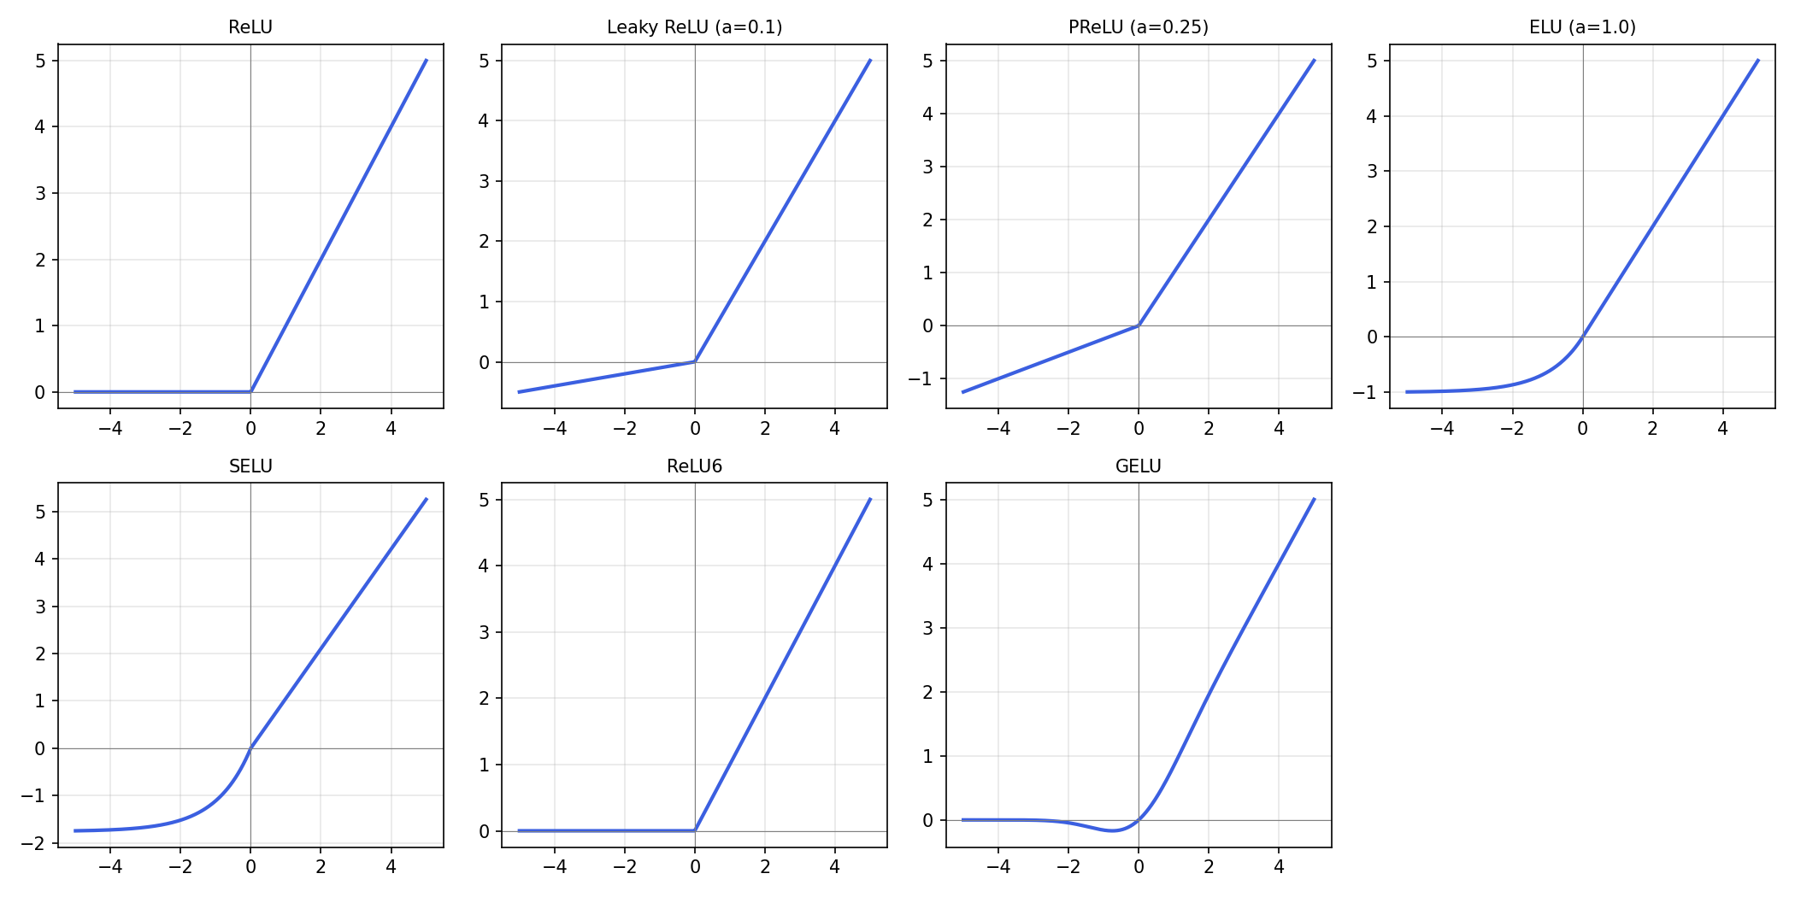

4. Comparing the Functions
Function | Gradient flow | Compute cost | Dead neurons | Typical use
ReLU | Strong for x>0, zero for x<0 | Very low | Yes — common | CNNs, default hidden layers
Leaky ReLU | Small but nonzero for x<0 | Very low | Rare | Drop-in ReLU replacement
PReLU | Learned slope for x<0 | Low (extra params) | Rare | Large image models
RReLU | Randomized slope for x<0 | Low | Rare | Regularization on small data
ELU | Smooth, nonzero for x<0 | Higher (exp) | Very rare | Deeper nets needing negative means
SELU | Self-normalizing | Higher (exp) | Very rare | Self-normalizing feed-forward nets
ReLU6 | Same as ReLU, capped at 6 | Very low | Yes — common | Mobile/quantized nets (MobileNet)
GELU | Smooth, small negative gradient | Higher (erf/tanh approx) | Very rare | Transformers (BERT, GPT)

5. Practical Guidance
- Default choice for most hidden layers: ReLU — cheap and effective, watch for dead neurons.
- Seeing many dead neurons? Try Leaky ReLU or PReLU.
- Need faster convergence in a deep net and can afford the compute? Try ELU.
- Building a plain self-normalizing feed-forward network? Use SELU with LeCun initialization.
- Targeting quantized/mobile deployment? Use ReLU6.
- Building a Transformer? Use GELU — the de facto standard in that family.

References
Nair, V., & Hinton, G. (2010). Rectified Linear Units Improve Restricted Boltzmann Machines. ICML.
Maas, A., Hannun, A., & Ng, A. (2013). Rectifier Nonlinearities Improve Neural Network Acoustic Models.
He, K., Zhang, X., Ren, S., & Sun, J. (2015). Delving Deep into Rectifiers (PReLU). ICCV.
Xu, B., Wang, N., Chen, T., & Li, M. (2015). Empirical Evaluation of Rectified Activations (RReLU).
Clevert, D., Unterthiner, T., & Hochreiter, S. (2016). Fast and Accurate Deep Network Learning by ELUs.
Klambauer, G., Unterthiner, T., Mayr, A., & Hochreiter, S. (2017). Self-Normalizing Neural Networks (SELU). NeurIPS.
Howard, A. et al. (2017). MobileNets: Efficient CNNs for Mobile Vision Applications (ReLU6).
Hendrycks, D., & Gimpel, K. (2016). Gaussian Error Linear Units (GELUs).
Note: citations above are provided from general knowledge and should be verified against the original sources before use in formal academic work.

